Direct Deposit Sub-system

System Documentation

Table of Contents
A. General Design 3
A.1. Definition of Terms 3
A.2. Development Tools and Utilities Used 3
A.3. Context Diagram 3
B. Database Architecture 5
C. Program Source Code 6
C.1. Development Standards 6
C.2. Location of Original Source Code 6
C.3. Location of Production Source Code 6
C.4. VB Design Overview 6
C.5. Use of Stored Procedures 7
D. Functional Design 8
D.1. Load FUNB Transaction File 8
D.2. Validate Transactions Screen 13
D.3. Pre-Edit File Screen 16
D.4. Post Transaction Screen 20
D.5. Balance Direct Deposit Screen 21
D.6. State Treasurer Screen 23
D.7. Reports Screen 27
D.8. Security-DDS Users Screen 28
D.9. Income Source Types Screen 31
D.10. DDS Configuration Screen 33
E. DDS External System Interfaces 35
E.1. HL7 Interface Design 35
F. DDS Installation Procedures 41
Attachment A – Logical Data Model A-1
Attachment B – Physical Data Model B-1
Attachment C – Development Standards C-1

A. General Design
This section provides an overview of the Direct Deposit Sub-system design. Unfamiliar terms and acronyms are defined. A list of tools used to develop and maintain the system is also provided.

A.1. Definition of Terms
A definition of unfamiliar terms and acronyms is provided in below.

Term | Definition
Affinity | Patient Management and Patient Accounting System at all State DMH/DD/SAS Institutions and the DHHS Controller’s Central Billing Office. Affinity is a product of the company Compucare.
DHHS | Department of Health and Human Services
DIRM | Division of Information Resource Management within DHHS
FUNB | First Union National Bank
HL7 | Health-Level 7. An industry recognized messaging format used by the healthcare industry to transfer commonly shared data between software application at different organizations.
modal | A dialog screen that requires user input before continuing.
NCAS | North Carolina Accounting System.
DBA | Database Administrator
DDS | Direct Deposit Subsystem
PA | Patient Accounting (Affinity)
PF | Personal Funds
PFS | Personal Funds Subsystem

A.2. Development Tools and Utilities Used
The following development tools, database management system and utilities were used to develop this application.

Tool Type | Product Name | Vendor Name | Version Number
DBMS | Adaptive Server Enterprise | Sybase | 11.9 (Unix);  11.5 (NT)
Stored Procedures | Transact-SQL | Sybase | 11.9 (Unix);  11.5 (NT)
GUI Development Tool | Visual Basic Enterprise | Microsoft | 6.0
Reporting Tool | Crystal Reports | Seagate Software | 7.0
Sybase Database Driver | SYSYBNT.DLL (NT)  SYSYB95.DLL (Win 95, 98) | Sybase | 3.01
Grid Control | Data Widgets | Sheridan | 3.1
Data Modeling Tool | PowerDesigner DataArchitect | PowerSoft | 6.1.1
Source Code Control | Visual Source Safe | Microsoft | 6.0

A.3. Context Diagram
The following diagram shows an overview of the system and its relationship to its external interfaces. Transactions are downloaded from First Union National Bank and the file is the input into Direct Deposit. Patient transactions that have been validated are posted to either Affinity Patient Accounting (PA) and/or the Personal Funds Subsystem (PFS). HL7 messages are created and sent to Compucare’s Affinity product (one-way interface – outbound only). Direct database updates are done to post funds to PFS. Data is also extracted from DDS and files are created and emailed to the North Carolina State Treasurer on a daily basis.

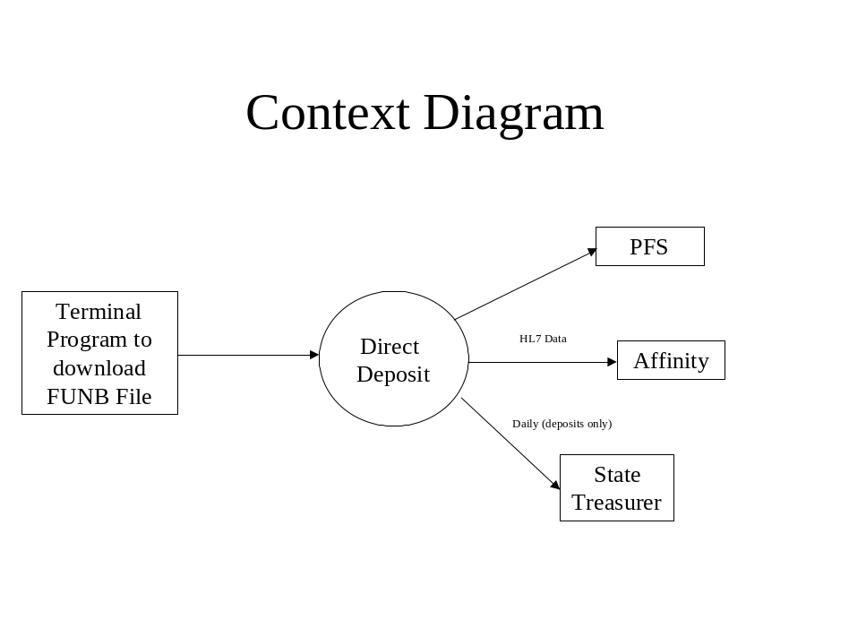

B. Database Architecture
The database was modeled using PowerSoft’s PowerDesigner DataArchitect tool. The data model conforms to relational database theory. Any changes identified during development were first incorporated into the logical data model and then generated into the physical data model.

The DataArchitect tool creates Sybase Data Definition Language (DDL) which is used to create database objects. The database creation script, which creates all tables, indices, and domains, was generated using the tool.

Database sizing was also done using the tool. Estimated row counts (after two years) were provided for each table and the tool used this information to provide an estimate of the database size. This information was used to define the size of database devices.

Once in production, any changes to the database should be reflected in both the logical and physical data models and the DDL generated from the tool. The DBA is responsible for keeping the data models and database in synch.

The DD Logical Data Model may be found at Attachment A of this document. The DD Physical Data Model may be found at Attachment B of this document.

Program Source Code

C.1. Development Standards
The project team agreed upon a set of development standards to be used while developing this software. This includes such things as naming standards, programming standards, and guidelines to use when creating the user interface. The standards are documented in a separate document and are included at Attachment C.

C.2. Location of Original Source Code
One of the difficulties working as a team is controlling whom has access to a particular portion of the PFS software. Microsoft’s Visual Source Safe (VSS) was chosen to help manage the project by saving various files (source code files, text files, graphics files, or binary files) to a database. All project software (Visual Basic (VB), C++, Stored Procedures) and documentation is managed using VSS. When a programmer adds a file to the project, the file is backed up on the database and made available to others. If anyone wants to make a revision to the source code, the developer checks the file out of the database. A copy of the file is placed into the developer’s working folder. If anyone else attempts to check out the same file for editing, a message will state that the file is already checked out. After the developer has finished editing the document, the developer checks the file into Visual Source Safe. Any changes that have been made to the file are saved so we can recover an old version of that file at any point in time. The members of the programming team can see the latest version of any file, make changes, and save a new version in the database.

The Visual Source Safe Database resides on a secure directory on the NT 4.0 Server in the directory \\currituck\VSS. Inside Visual Source Safe the code resides in folder HEARTS\Direct Deposit\VBDevelopment. The Visual Source Safe database is backed up according to OAO backup procedures.

From the design phase all the way to the installation phase, the VB project was frozen at various stages as an added precaution. An executable of the application was created and labeled together with the executable’s related source code. The label was marked with the date and stage of development and placed in the Visual Source Safe Directory Database. From Visual Source Safe the history of the application can be shown so a view of the application at a particular phase can be recreated.

C.3. Location of Production Source Code
There are two types of compiled source code in Direct Deposit: the main VB application that the majority of the users see; a small DLL that creates the HL7 message. Other source code includes Sybase stored procedures that are stored in the database.

Since the application will be used only at Albemarle Building. The main VB application executable resides on one main server. Each user is served the application from this central server. If the application executable is rebuilt and re-deployed, then a copy of the executable must be replaced. The small DLL that creates the HL7 messages will reside on the server as well.

The Sybase database (including all stored procedures) is stored centrally on the server hes001.dhr.nc.state.us, which is located in Raleigh.

C.4. VB Design Overview
Before any screens were created or a single line of code was written, careful consideration was given to the design methodologies and standards that were to be used for the DD project. Visual Basic programming standards were drafted and approved by the developers on the team. All requirement documents were thoroughly reviewed. A top to bottom design philosophy was utilized for this project. All high level requirements were identified first and these high-level requirements were broken down into major functions and into smaller components until the low-level requirements were identified.

Once OAO’s understanding of the requirements was complete, the application prototype could begin. OAO wanted the look and feel to resemble HEARTS Personal Funds Subsystem so the users would not have to learn another interface. Next we needed to determine if any additional programming tools or controls were needed to achieve the GUI interface. The programming staff decided to stay with the grid design control used in PFS. Three other controls, the Outlook Toolbar, Outlook titlebar and the date selector were used to meet the needs of the GUI Interface.

Once the look and feel of the interface was decided upon, the major functions of the application needed to be designed. The major functions were assigned to individual programmers and each developer was responsible for creating a design specification document and the prototype screen for the major function. This design specification was to identify each sub function, each control on the screen, and the purpose for each control and sub function. During the creation of the design specification document, the requirement matrix was referenced to see if each main function contained all the functionality required by the user. Refer to section D “Functional Design” for more information. Once the design specification document was complete, the developer could create the prototype screen keeping the design specification document in mind.

C.5. Use of Stored Procedures
In order to enhance security and flexibility of the DD application, stored procedures were used extensively in the development of the DD Subsystem. Stored procedures are a precompiled collection of SQL statements and optional flow control statements that are stored and processed as a unit. They can accept input parameters, return output parameters, return single or multiple result sets, and return values. Stored procedures have many distinct advantages over conventional SQL statements.

- Data integrity is more protected.
- Maintenance can be performed at the database level instead of recompiling the application.
- You can execute a series of SQL statements in a single stored procedure.
- You can reference other stored procedures from within your stored procedure, which can simplify a series of complex statements.
- The stored procedure is compiled on the server when it is created, so it executes faster than individual SQL statements.

As a strict rule enforced on the application, all inserts, updates and deletes of records are executed only from stored procedures. Therefore no actual changes are made to the database from the VB application executable. Instead all changes are made from within the database itself. This technique also protects the data. Users are given permission to execute the stored procedures along with permission to read the data files. No users are given direct permission to add, update or delete any DD table in the database – all updates must be done using the stored procedures that are called from the VB application.

D. Functional Design
The following information is provided as an overview of DDS major functions. Additional information is provided in the source code comments.

D.1. Load FUNB Transaction File

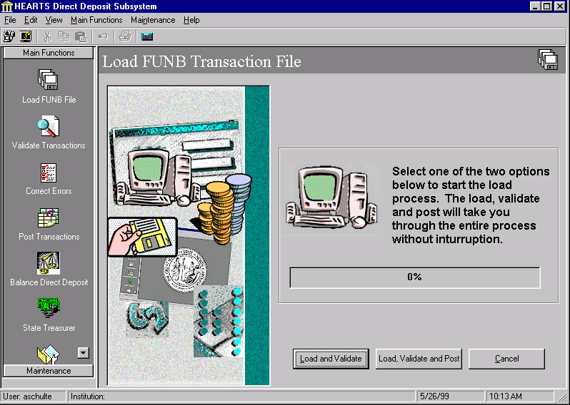
Every day the FUNB transaction file is downloaded from First Union National Bank. These deposit transactions need to be loaded into the Direct Deposit application. When the Load FUNB Transaction File screen is activated, the screen will give the user a choice to load and validate the file or to load, validate and post the FUNB transactions.

Control | Control Type | Comments
Load And Validate Button | Command button
Load, Validate and Post Button | Command button | If this button is selected, the file will be loaded and then it goes directly to the validate transaction screen. After validation, the posting process is performed.
Loading Progress bar | Progress bar | This control will tell how far along you are in the process.
Cancel button | Text Box

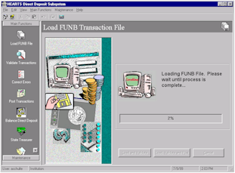The Load Process
Once the user clicks either button, the Load FUNB File Dialog will appear. The user must select the location (local or network drive) of the FUNB file. When the user selects OK, the application will lock the use of the loading, validating or posting from any other users. The dialog will disappear and the file will be loaded into the system. The loading process will read the file line by line and for each detail record read, a record will be written to the work file. The loading process will check to make sure the file is valid. The sender and receiver identification will be verified and summary totals will be calculated and verified. For each header type record received, a matching trailer record must be identified. If any of these checks fail, the file will not load and the validation process will stop. If the load file is valid, the summary information for the file will be written to the summary control file.

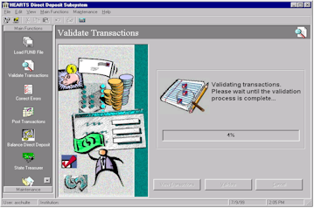The Validation Process
Once the file has been completely loaded with no errors encountered, the Validate Transaction screen will appear and start validating each detail record. The logic for this section will be described in the section Validate Transactions. There are two different outcomes that may occur when validation has finished. If the user clicked the Load and validate button, the Pre-Edit report and the Deceased Exceptions report will appear on the screen and the application will be unlocked for other users. If the user clicked the Load, Validate and Post, the Validate Transactions screen will close and the Post Transactions screen will appear.

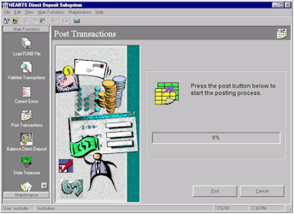
The Posting Process
If the user clicked the Load, Validate and Post button and Validation has ended, the Post transactions screen will appear. The posting will begin automatically sending the valid records to Affinity and PFS. Once complete, the Pre-Edit report, the Deceased Exceptions report, and the Direct Deposit Detail and Summary report will appear on the screen and the application will be unlocked for other users.

D.1.1. File Input
The FUNB file received is a comma-delimited file with multiple record types. A summary of the record types and the file grouping is shown below.

01 – File Header
This record marks the beginning of the file. This record contains the sender and receiver ids and contains a unique number to identify the file. This record also contains the date the file was created

02 – Group Header
This record identifies a group of accounts. This record also indicates the date of when the data was finalized

03 – Account Identifier and Summary
This record identifies the account number and reports summary and status information

16 – Transaction Detail
This record reports transaction detail with accompanying text, transaction types, amounts and reference numbers

49 – Account Trailer
This record is the trailer for the Account Identifier and Summary Record. This will indicate the number of type 16 records and summarize the total for the account

98 - Group Trailer
This record is the trailer for the Group Header Record. This will indicates the summary totals for the group

99 – File Trailer
This record is the trailer for the File Header Record. This will indicate the summary information for the entire file

88 – Continuation Record
This record is used to continue a record type. For the BAI File there are two continuation records that are of importance. One occurrence is after an account header record. This continuation record will have further summary information. Also for each transaction detail three continuation records will follow containing free for text of the

D.1.2. Sample FUNB File

EXECUTION OF PDD600 HAS BEEN STARTED. PLEASE WAIT ......
01,053000219,0000000511,990616,1320,1320,78,,2/
02,0000000511,053000219,1,990601,2400,USD,2/
03,002000000127884,USD,015,6132617,,,040,6132617,,,045,6132617,,,063,0,,/
88,072,0,,,074,0,,,075,0,,,100,3521546,157,,400,0,0,,050,6132617,,/
16,165,198900,S,198900,0,0,0029461279,/
88,AUTOMATED CREDIT US TREASURY 220 VA BENEFIT
88,CO. ID. 3111036002 990601 PPD
88,MISC 29461279 00 18
16,165,132994,S,132994,0,0,0000000000,/
88,AUTOMATED CREDIT US TREASURY 307 RR RET
88,CO. ID. 3071036003 990601 PPD
88,MISC WA240090887 1
16,165,128100,S,128100,0,0,3101036009,/
88,AUTOMATED CREDIT USCG TREAS 310 FED SALARY
88,CO. ID. 3101036009 990601 PPD
88,MISC 244086076690253
16,165,122000,S,122000,0,0,0009067294,/
88,AUTOMATED CREDIT US TREASURY 220 VA BENEFIT
88,CO. ID. 3111036002 990601 PPD
88,MISC 09067294 00 18
16,165,104261,S,104261,0,0,0000000000,/
88,AUTOMATED CREDIT US TREASURY 307 RR RET
88,CO. ID. 3071036003 990601 PPD
88,MISC WA000616953 1
16,165,91440,S,91440,0,0,3121036092,/
88,AUTOMATED CREDIT US TREASURY 312 SOC SEC
88,CO. ID. 3121036092 990601 PPD
88,MISC 556486810C1 SSA
49,31573560,631/
98,31573560,1,633/
99,31573560,1,635/

INVISION HAS COMPLETED YOUR REPORT .... PLEASE CONTACT YOUR
FIRST UNION REPRESENTATIVE IF YOU REQUIRE ADDITIONAL ASSISTANCE.

ENTER REPORT NUMBER OR NAME

D.1.3. Main Logic for Load

Open the FUNB File
Do Until End Of File
Update Progress Indicator
If Record Code “01”
If Sender and Receiver Id’s are incorrect
Raise an Error
Else
If File was previously processed
Raise Error
Else
Store File Date/Time and File Identification Number
InFile = True
End IF
End IF
Else If Record Code = “02” Then
If InGroup = True Then
Error Occured
Else
InGroup = True
End IF
Case “03”
If InAccount = True Then
Error Occurred
Else
If InGroup = False Then
Error Occurred
Else
InAccount = True
End IF
End IF
Case “16”
If InGroup = False Or InAccount = False Then
Error Occurred
Else
Write Record to Work File
Add to accumulators
End IF
Case “49”
If InAccount = False Then
Error Occurred
Else
InAccount = False
Check Account Accums
End If
Case “98”
If InGroup = False Then
Error Occurred
Else
InGroup = False
Check Group Accums
End If
Case “99”
If InGroup = True Or InAccount = True Then
Error Occurred
Else
Check File Accums
End IF
Case “88”
Continue Previous Record
Case Else
Error Occurred
End Select

If Error Occurred Then
Exit Loop and show user the error
Else
Read Next Record
End IF
Loop

If Errors Occurred
Delete Detail Records from the work table
Else
Update the summary table with the type “02” records (There should only be one of these)
End IF

D.2. Validate Transactions Screen

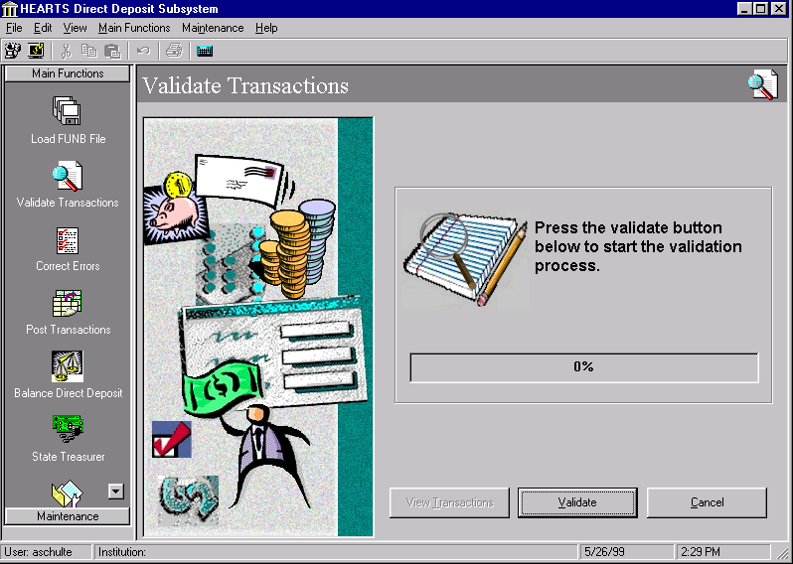
The Validate Transaction Screen is used to check which transactions can be posted. There are two different modes of entering this screen. The first mode of entering the screen is from the Load FUNB File screen. After the load of the FUNB file the validation process begins immediately. In this case, the records in the pre-edit file are appended to the records just loaded in the work table. The validation starts on all the records in the work table. The validation checks can be viewed in the logic flowchart. The progress of the validation will be updated continuously to the user. Any records that pass the validations are placed in the valid records table and stay there until posted. If a record fails validation, the record will be placed in the pre-edit table. Once validation is complete the View Transactions button will be enabled. If the user click this button, the user will see a grid showing the records that passed validation. The grid will show account information and amounts to be posted to Affinity PA and/or PFS.

If there are records in the pre-edit file the user can recursively validate the records in the pre-edit file. To do this the user would click the Validate Transactions icon from the vertical toolbar. The user will receive a message to press the Validate button to start the validation process. Once the user clicks the button, the records in the pre-edit file will be appended to the work table. The validation starts on all the records in the work table. The validation checks can be viewed in the logic flowchart. The progress of the validation will be updated continuously to the user. Any records that pass the validations are placed in the valid records table and stay there until posted. If a record fails validation, the record will be placed in the pre-edit table. Once validation is complete the View Transactions button will be enabled. If the user click this button the user will see a grid showing the records that passed validation. The grid will show account information and amounts to be posted to Affinity PA and/or PFS.

Control | Control Type | Comments
Validate Button | Command button | This button will start the validation process
View Transactions Button | Command button | Enabled after the transactions have been validated. Displays a grid of the transactions that passed the validations.
Validation Progress Bar | Progress bar
Cancel button | Command Button

Write the record
to pre-edit report
and file
Is the income source type valid?
Is the benefit amount a credit?
Does the current visit’s campus = the current ATP/PML Responsible Payee?
Is the record a PML record?
Is the total of PA and PF benefit amount > zero?
Read Next work file record and repeat A until end of file
Create record in valid records table
Find the most current visit for the patient that has a campus that matches the latest ATP/PML Record.

Move records from pre-edit-file to work file
Read first Work file record
D.2.1 Validation Flowchart

A

Is DD Number blank or zeroes

Is there a ATP / PML Record with a matching DD Number?

Is there a matching patient record?

Write the record
to pre-edit file and
Deceased Exception
Report
Is the patient deceased?

Is the benefit amount a credit?

Find the most current visit for the patient.

Find the most current visit for the patient that has a campus that matches the latest ATP/PML Record.

Does the current visit’s campus = the current ATP/PML Responsible Payee?

Is the income source type valid?

Is the record a PML record?
Find current active rate in effect for the current month
Find most current active rate in effect at the end of the prior month

Is the total of PA and PF benefit amount > zero?
Create record in valid records table

Write the record
to pre-edit report
and file
Read Next work file record and repeat A until end of file

D.3. Pre-Edit File Screen
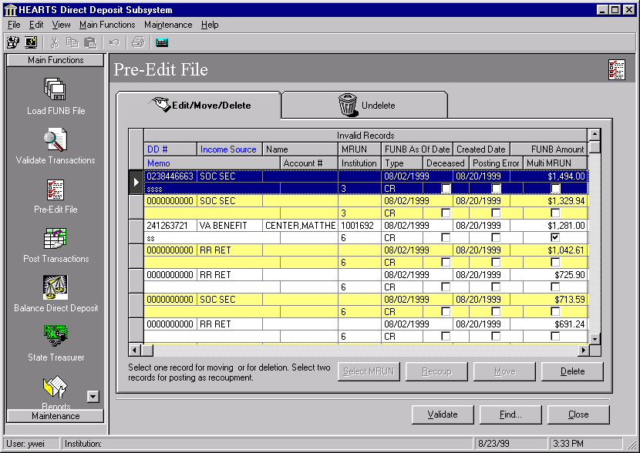

The Pre-Edit Maintenance Screen is a MDI child and must fill the entire workspace of the Main Screen. It is used to update records that failed the validation process. This screen does not utilize the toolbar.

When the user enters this screen, the grid in Edit/Move/Delete tab will show the records in Invalid Records table. The following objects are needed for Pre-Edit Maintenance Screen.

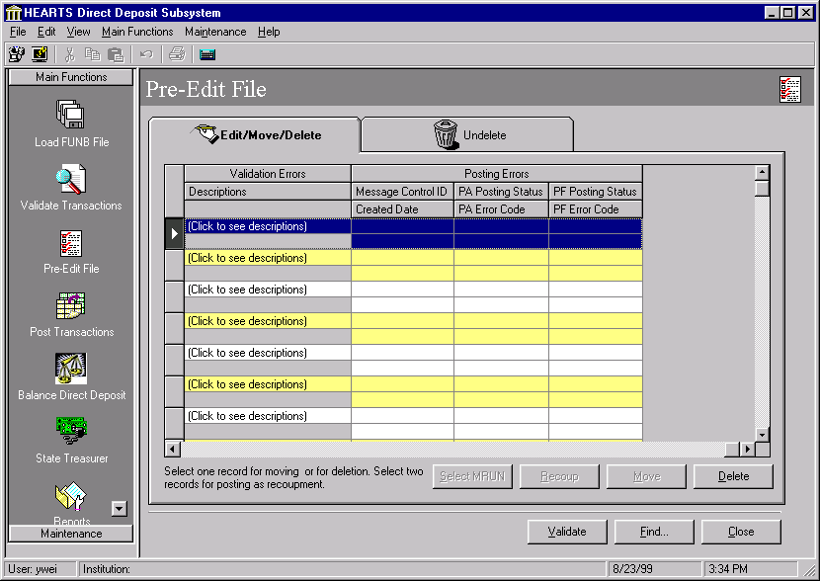
Field | Control Type | Group | Comments
Edit/Move/Delete tab | Sheridan tab control
Invalid Records grid | Sheridan data grid | Edit/Move/Delete Group
Select MRUN button | Command button | Edit/Move/Delete Group
Recoup button | Command button | Edit/Move/Delete Group
Move button | Command button | Edit/Move/Delete Group
Delete button | Command button | Edit/Move/Delete Group
Undelete tab | Sheridan tab control | Undelete Group
Deleted Invalid Records grid | Sheridan data grid | Undelete Group
Purge button | Command button | Undelete Group
Undelete button | Command button | Undelete Group
Validate button | Command button
Find button | Command button
Close button | Command button
The Pre-Edit maintenance Screen is used to maintain records in Invalid Records table. It provides the following functions:
- Edit records from invalid records table.
- Move records from invalid records table to valid records table.
- Recoup deceased patients’ PFS transactions.
- Delete records from invalid records table.
- Purge records from invalid records table.
- Undelete records from invalid records table.
- Find a specific record in invalid records table.
- Validate invalid records

Edit records from invalid records table
User can directly edit records in Invalid Records grid. Only the highlighted columns are editable fields. The rest of the columns are locked and not available to user. Clicking on the cell of Income Source column would bring up a dropdown combo box for user to select a valid source type. Note that none of the columns in Deleted Invalid Records grid are editable.

Move records from invalid records table to valid records table
This function is provided by the Move button in the Edit/Move/Delete tab. Initially, the move button is disabled. It will be enabled, once the user select a record for deceased patient in Invalid Records grid. The record to be moved should be for deceased patient and it’s a credit transaction. The system would prompt user for confirmation before the changes can be made. The grid would be refreshed after the Move function has been carried out.

Recoup deceased patients’ PFS transactions.
This function is provided by the Recoup button in the Edit/Move/Delete tab. Initially, the recoup button is disabled. It will be enabled, once the user select two matching records for deceased patient in Invalid Records grid. The records to be recouped should be for deceased patient and one should be credit one should be debit. The program also checks the DD#, FUNB amount, income source type, MRUN and institution code to make sure these two are really a matching pair. The system would prompt user for confirmation before the changes can be made. The grid would be refreshed after the Recoup function has been carried out.

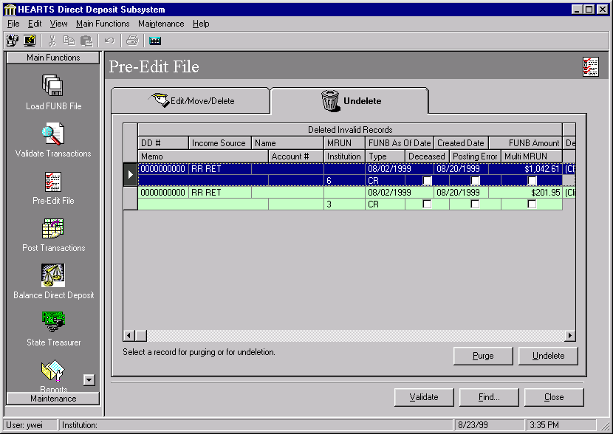
Delete records from invalid records table
User can delete records clicking on the Delete button in the Edit/Move/Delete tab. Like the Move button, it’s enabled only after user selects records from the grid. System would also prompt user for confirmation. This grid and the other grid in Undelete tab are refreshed after user clicks on Yes in the message box. The deleted records would be removed from the invalid records grid, and they would be shown in the deleted invalid records grid. Once the records are deleted, the records still reside in the database table only their record status are marked as I(inactive). User needs to use Purge button in Undelete tab in order to permanently remove the records from the database.

Purge records from invalid records table
Clicking on the purge button in the Undelete tab would purge the selected records. System would prompt the user for confirmation. Once this function is executed, the changes are permanent. The grid would be refreshed to show the changes. Purge and Undelete buttons are enabled only if user has selected records in the deleted invalid record grid.

Undelete records from invalid records table
User can undelete records clicking on the Undelete button. System would prompt the user for confirmation. Upon completion the records would be removed from Deleted Invalid Records grid and added to Invalid Records grid. Both grids would be refreshed.

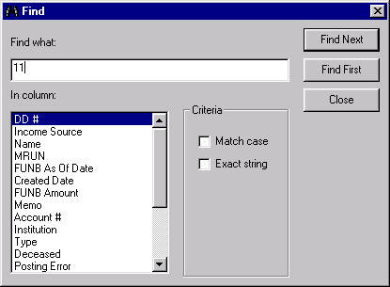

Find a specific record in Pre-Edit File
Click on the Find… button to bring up this Find dialog screen to search for a specific record using a supplied expression. Click on the listbox to pick a column to search. Check the Match case checkbox to enable case-sensitive searching. Click on the Exact string checkbox to enable exact string searching. Click on the Find Next button to find the next occurrence of the string. Click on the Find First button to find the first occurrence of the string. Click on the Close button to close the screen. If a match is found, the dialog closes out and the grid would show the matched record. If no match is found, the program would show a message box to notify user and dialog remains open for the user to input the search string again.

D.4. Post Transaction Screen

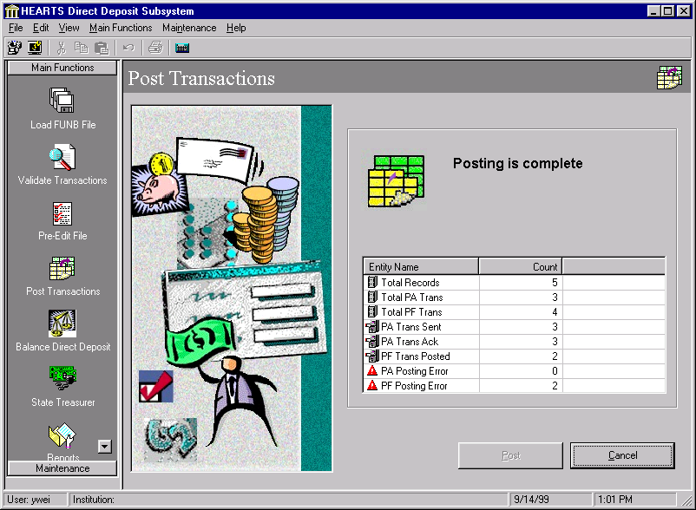
The Post transactions Screen main objective is to post funds to the personal funds and patient accounts. There are two ways to post the transactions. One way is to go to the Load FUNB File option and click the Load, Validate and Post button. The other way is to click the Post button on the Post Transactions screen. If posting is not done at the same time as the load and validate process, then the records in the valid table will once again be validated to make sure they are still valid (no account changes were made since last validated). The validation will not occur twice if the Load, Validate and Post button is selected. The validation will occur in the current screen and the status will be shown periodically. When entering the screen, the progress section will tell the user to click the Post button to begin the posting process. The validation logic for posting is practically identical to the logic in the Validate Transactions screen except the logic will check the valid records table instead of the work table filled with the records from the pre-edit file. Once the validation is finished, the posting process will start at the beginning of the Valid Records Table. The portion of the benefit amount will have already been calculated in the validation process. Hl7 will be used to post the valid records to Affinity. After we post a benefit payment in Affinity we need to make sure we get an acknowledgement back from Affinity. Once the acknowledgement arrives, the medical record number found in Affinity will be used to post a transaction to Personal Funds if the PF amount is greater than zero. If any record fails in HL7, the record will be written to the pre-edit table. Once posting is complete, the Detail and Summary Report will appear on screen for the user to print.

A list view is used to summarize the posting process. The first three items are set when the user clicks the Post button. The “Total Records” shows the number of records in DD_VALID_REC table that need to be posted. The “Total PA Trans” shows the number of Affinity transactions while the “Total PF Trans” indicates the number of PFS transactions. The rest of the items are changing during posting process to indicate the progress of the posting. The posting to PA is a two-stage process. The “PA Trans Sent” shows the number of PA transactions that have been sent and The “PA Trans Ack” shows the number of acknowledgements that have been received. The “PF Trans Posted” indicates the number of transactions posted to PFS. The “PA Posting Error” and “PF Posting Error” shows the number of error posting to Affinity and PFS, respectively. After the posting is completed, the sum of “PF Trans Posted” and “PF Posting Error” should be equal to “Total PF Trans”. “PA Trans Sent” and “PA Trans Ack” should also be both equal to “Total PA Trans”. Transactions that received errors during the posting process are sent back to the Pre-Edit file for resolution.

Control | Control Type | Comments
Post Button | Command button | This button will start the posting process
Status View | List View
Cancel button | Command Button

D.5. Balance Direct Deposit Screen

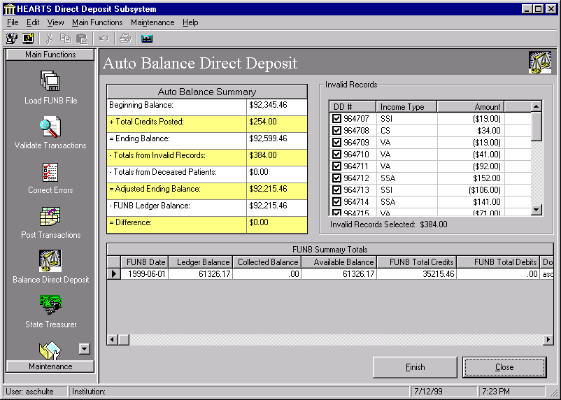
The Auto Balance Direct Deposit Screen consists of three main sections to aid in balancing Direct Deposit. One section is the Auto Balance summary. This section shows the complete step by step process to find the daily adjusted ending balance. The next section is for invalid records (from Pre-Edit and Deceased Exceptions reports). This section provides a minimal view of the invalid records. The only columns shown are the Direct Deposit Number, the FUNB income source type, the total benefit amount and the deceased indicator. Sorting is allowed by clicking the column you wish to sort. If you toggle the column header, the column will alternate from ascending to descending sorting. As an aid to the reconciliation process, you can click the check box next to the DD# to add or subtract the benefit amount from the Invalid Records Selected text box. By no means will selecting or deselecting an invalid amount, change the amount of Totals from Invalid Records in the Auto Balance Summary. The third section shows the information from the FUNB Summary table. This section will show ten days worth of data about FUNB files that have been loaded. When Direct Deposit has been balanced, the user would click the Finish button to update the new Beginning balance with the Ending Balance. The program will check to make sure the difference between the Adjusted Ending Balance and the most recent FUNB Ledger Balance is zero. If the difference is not zero, a message is displayed to the user asking if they really want to finish with Auto Balance. The balance process may be saved regardless of whether the system is in balance or not. After the beginning balance is updated, the Auto Balancing Worksheet Report will appear on screen for the user to print.

Control | Control Type | Comments
Finish Button | Command button | This button will start the posting process
Auto Balance Summary Grid | Sheridan Data Grid
Invalid Records Grid | Data View
Invalid Records Selected Label | Label Control | Read only view of the invalid records selected
FUNB Summary Totals Grid | Sheridan Data Grid
Cancel button | Command Button

D.6. State Treasurer Screen
The following sections detail the programming specifications for the State Treasurer screen. The State Treasurer screen is used to produce two sets of files for the State Treasurer (one for personal funds deposits and for patient account payments). Also, this screen allows the users to email these files and to print them. The State Treasurer screen is designed using one control button called “Process” which includes the following four component processes:

- Enter the Deposit Sequence Number
- Create Deposit Totals Files
- E-mail Files
- Print Files

The State Treasurer screen is a MDI child and must fill the entire workspace of the Main Screen. In order to accomplish this the screen needs to resize the form and controls to fit the dimensions of the workspace section any time the main form is resized (resolution of 800*600 or greater is necessary).
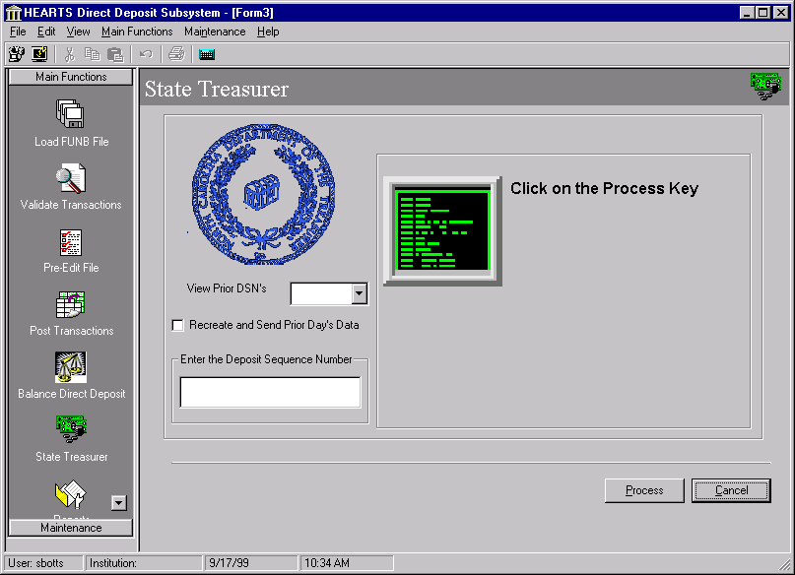

D.6.1. Entering the Deposit Sequence Number
When the user enter the deposit sequence number (DSN) and then clicks the Process button, this sequence number is saved to a control file. DSN’s used in the past may be viewed by clicking on the ‘View Prior DSN’s’ dropdown box. The following data validation is performed for DSN’s that are entered:

- Only accept numeric data entry
- Prevent duplicate DSN’s from entering the system

If an error is detected, a modal dialog is displayed to indicate what type of data entry error has occurred. If no error is detected, the process will start by first creating the deposit totals files, then sending (emailing) those files to the State Treasurer, and finally printing those files to the local default printer.

Alternatively, files previously created and sent may be re-created and sent. To do this, click on the ‘Recreate and send prior day’s data’ checkbox. The DSN textbox will disappear and a date control will appear. Select the date (or type in the date) for which the files should be created for. Only a single day’s data may be recreated at one time.

The following objects are needed for the State Treasurer’s screen:

Field | Control Type | Comments
ChkPriorDayData | Checkbox
sdcDSN | SsOleDBCombo
TxtDSN | TextBox
ProgressBar1 | ProgressBar
ProgressBar2 | ProgressBar
CmdProcess | Command Button
CmdCancel | Command Button
DtStart | Date Selector | Hidden until checkbox is checked.

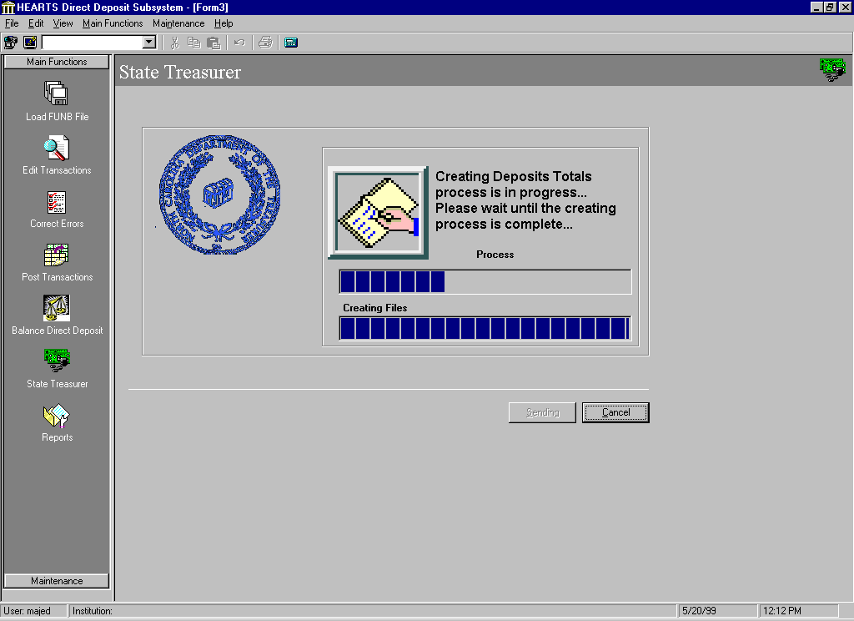
D.6.2. Create Deposit Totals Process

When the user clicks the Process button, it is disabled and changed to Creating button. The user will see two progress bars active and running. The one on the top shows the status of the overall process. The second one, on the bottom, shows the status of the creating files process.

If the user clicks on Cancel, a modal dialog will be displayed asking if they want to abandon changes.

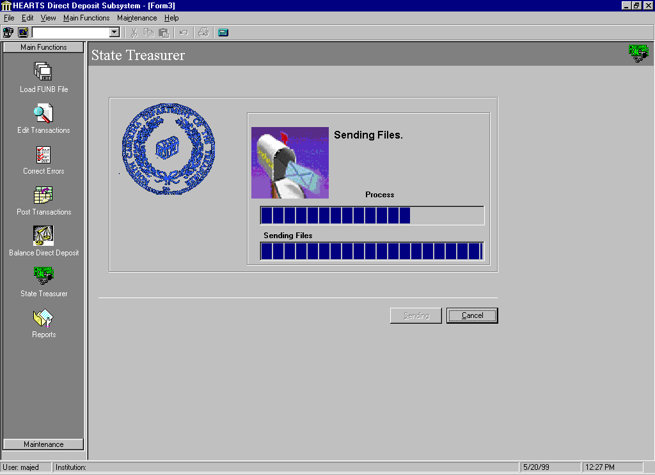
D.6.3. Send E-mail Process

When the user enters the Send Email process, Process button is disabled and changed to Sending. The second progress bar, on the bottom, shows the status of the sending files process. The email options can be modified using the Maintenance screen DDS Configuration. See the maintenance screen design specifications for more information.

D.6.4. Print File Process
When the user enters the Print Batch File process, the Process button is disabled and changed to Printing. The second progress bar, on the bottom, shows the status of the printing process.

Once the whole process is complete with no errors founds, the user will get a message box as below:
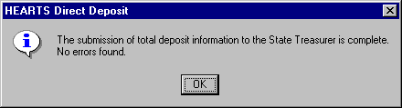
The user will click OK and the final screen will appear as below:
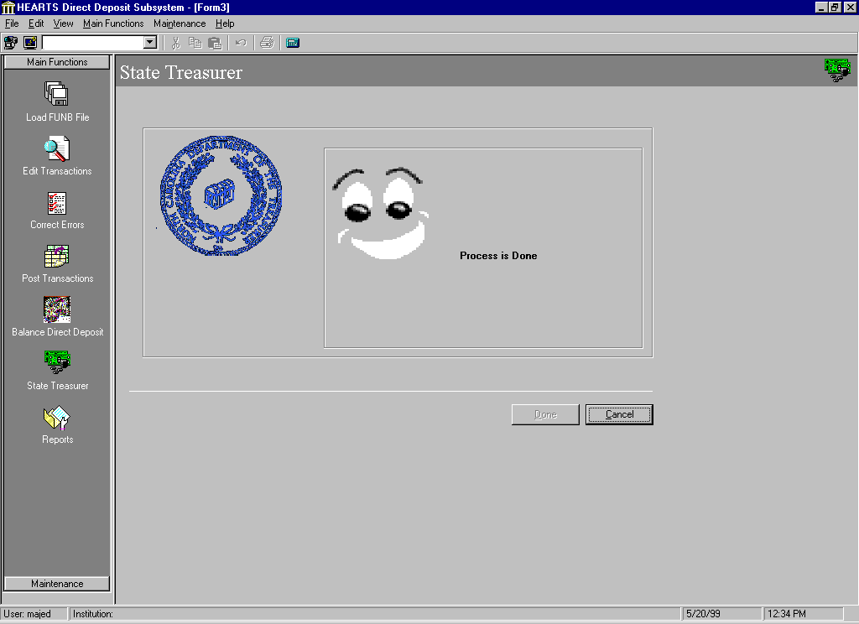

D.7. Reports Screen
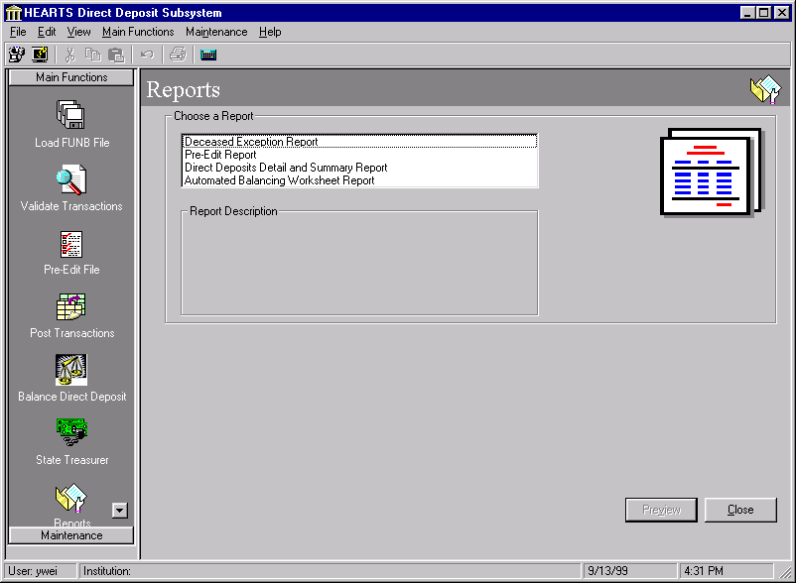
There are 4 reports in DDS that can be accessed through the Report screen. They are:
- Pre-Edit Report
- Deceased Exception Report
- Direct Deposit Detail and Summary Report
- Automated Balancing Worksheet Report

D.7.1. Pre-Edit Report
This report is generated from the DD_INVALID_REC table and is sorted by FUNB as of date. The layout of the report is shown in the following figure.

D.7.2. Deceased Exception Report
This report is generated from the DD_INVALID_REC table and is sorted by Institution Name, Income Source Type, Client Name and FUNB as of Date. This report is for discharged patient due to death.

D.7.3 Direct Deposit Detail and Summary Report
This report is generated after posting process is complete and will identify accounts that resulted in actual deposits to personal funds and/or patient accounting systems for the current day. This report is sorted by Institution Name, ATP or PML, Income Source, Client Name and FUNB as of date.

D.7.4 Automated Balancing Worksheet
This report is generated as a result of the Automated Balance process and contains a record of the results of balance process.

D.8. Security-DDS Users Screen
The Security-DDS Security Screen is a MDI child and must fill the entire workspace of the Main Screen. In order to accomplish this the screen needs to resize the form and controls to fit the dimensions of the workspace section any time the main form is resized (resolution of 800*600 or greater is necessary).

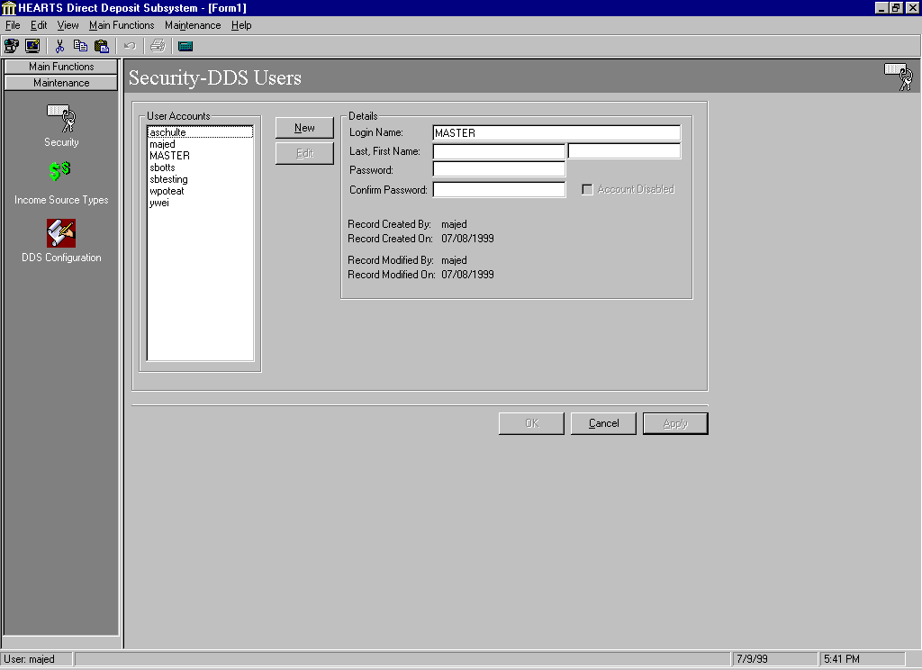
When the user enters this screen, all user accounts are displayed in the User Accounts list. The fields in the Details section of the screen are read-only when entering the screen. The following objects are needed for the Security Screen:

Field | Control Type | Group | Comments
LstUsers | ListBox | User Accounts
TxtUserID | TextBox | Details | Mandatory
TxtLastName | TextBox | Details | Mandatory
TxtFirstName | TextBox | Details | Mandatory
TxtPassword | TextBox | Details | Mandatory
TxtPasswordConfirm | TextBox | Details | Mandatory
ChkDisabled | CheckBox | Details
EdbUserID | MaskEdBox
TxtCreatedBy | TextBox | Details | Mandatory, updated programmatically
TxtCreatedDate | TextBox | Details | Mandatory, updated programmatically
TxtModifiedBy | TextBox | Details | Updated programmatically
TxtModifiedDate | TextBox | Details | Updated programmatically
Record Created By | Label | Details
Record Created On | Label | Details
Record Modified By | Label | Details
Record Modified On | Label | Details
Login Name: | Label | Details
Last, First Name: | Label | Details
Password: | Label | Details
Confirm Password: | Label | Details
Code: | Label | Details
Description: | Label | Details
New | Command Button
Edit | Command Button
OK | Command Button
Cancel | Command Button
Apply | Command Button

This screen serves three primary goals as follows:

- Display user accounts
- Add a new user account
- Modify an existing user account:
- Reset/change user password
- Enable user account
- Disable user account

Display User Accounts
The list of all user accounts is shown. Data is read-only.

Add a new User Account
To add a new user account, click on the Add button. New, Edit, and Delete buttons are disabled. All the fields in the Details section will be cleared, and become editable. The cursor will be positioned in the Login Name field. The OK and Apply buttons are enabled. When the user clicks OK or Apply, the following data validation is done:

- check for existence of Sybase login
- check for existence of Sybase user in the DDS database
- check for existence of user name in USER table
- check for entry of required fields
- check for minimum length of password
- check for password = confirm password

Modal dialog(s) are displayed to indicate what type of data entry error has occurred. If the user clicks on Cancel, a modal dialog will be displayed asking if they want to abandon changes. If the user clicks on OK or Apply and the data entered passes the data validation logic, update the database (insert). Refresh the screen with changes.

Note: If a user has access to both PFS and DDS, then they may use the same login for both systems.

Modify an existing User Account
To modify an existing user account, the user selects an entry from the User Accounts section (list) and clicks on the Edit button. The New, Edit, and Delete buttons are disabled. The OK and Apply buttons are enabled. All fields except the login name in the Details section will become editable. The cursor will be positioned in the Last Name field. When the user clicks OK or Apply, the following data validation is done:

- check for entry of required fields
- check for minimum length of password
- check for password = confirm password

Modal dialog(s) are displayed to indicate what type of data entry error has occurred. If the user clicks on Cancel, a modal dialog will be displayed asking if they want to abandon changes. If the user clicks on OK or Apply and the data entered passes the data validation logic, update the database. Refresh the screen with changes.

Disable an existing User Account
To disable a user, modify the account and select the Account Disabled Checkbox. This will mark the user record status inactive in the USER table and also lock the Sybase login for that user. This functionality is available when entering new users or editing an existing user.

Enable an existing User Account
To enable a user, modify the account and de-select the Account Disabled Checkbox. This will mark the user record status active in the DD_USER table and also unlock the Sybase login for that user. This functionality is available when entering new users or editing an existing user.

Reset/Change User Password
To reset or change user’s password select the user, click on the edit button, and enter the new password in the Password and Confirm password fields. If there is a change detected in either of the fields, then the new password is passed to the update procedure and the Sybase login password is updated. Password and Confirm password values must pass data validation (see data validation for “Modify an existing User Account”).

Note: If a user has access to both PFS and DDS, then changing the password here will change it for both systems.

D.9. Income Source Types Screen
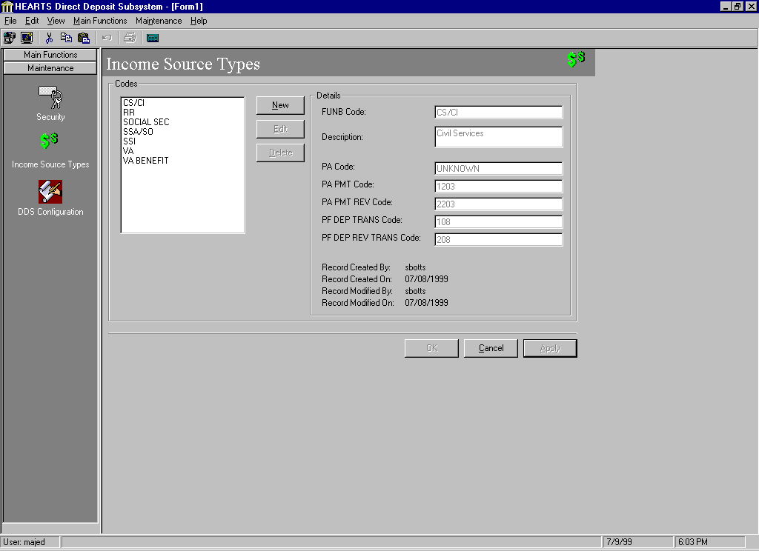
The Income Source Types screen is a MDI child and must fill the entire workspace of the Main Screen. In order to accomplish this the screen needs to resize the form and controls to fit the dimensions of the workspace section any time the main form is resized (resolution of 800*600 or greater is necessary).

When the user enters this screen, the OK and Apply buttons are enabled and all active codes are displayed in the Codes section (list). The first selection in the list will be highlighted with detail data displayed on the right for that selection. The fields in the Details section of the screen are read-only when entering the screen. The following objects are needed for the Income Source Types Screen:

Field | Control Type | Group | Comments
LstIncomeSource | ListBox | Codes
TxtCode | TextBox | Details | Mandatory
TxtDescription | TextBox | Details | Mandatory
TxtCreatedBy | TextBox | Details | Mandatory, updated programmatically
TxtCreatedDate | TextBox | Details | Mandatory, updated programmatically
TxtModifiedBy | TextBox | Details | Updated programmatically
TxtModifiedDate | TextBox | Details | Updated programmatically
txtPACode | TextBox | Details
txtPAPMTCode | TextBox | Details
txtPAPMTREVCode | TextBox | Details
txtPFDEPREVTRANSCode | TextBox | Details
FUNB Code: | Label | Details
Description: | Label | Details
PA Code: | Label | Details
PA PMT Code: | Label | Details
PA PMT REV Code: | Label | Details
PF DEP REV TRANS Code: | Label | Details
Record Created By: | Label | Details
Record Created On: | Label | Details
Record Modified By: | Label | Details
Record Modified On: | Label | Details
New | Command Button
Edit | Command Button
Delete | Command Button
OK | Command Button
Cancel | Command Button
Apply | Command Button

The Income Source Types Screen is used to view, modify, and delete Income Source Types codes. This screen serves four primary goals as follows:

- Display active codes
- Add a new code to the system
- Modify an existing code
- Delete an existing code

Display active Income Source Types Codes
Upon entering the screen all active codes in the Income Source Types table are displayed. Data is read-only.

Add a new Income Source Types Code
To add a new code the user would click on the Add button. New, Edit, and Delete buttons are disabled. All the fields in the Details section will be cleared, and become editable. The cursor will be positioned in the Code field. The OK and Apply buttons are enabled. If the user clicks on OK or Apply and required fields are blank, a modal dialog will be displayed saying that required fields must be entered. If the user clicks on Cancel and data has been entered, a modal dialog will be displayed asking if they want to abandon changes. If the OK or Apply button is clicked and required fields pass data validation, update the database (insert). Refresh the screen with changes.

Modify an existing Income Source Types Code
To modify an existing code, the user selects an entry from the Codes section (list) and clicks on the Edit button. The New, Edit, and Delete buttons are disabled. The OK and Apply buttons are enabled. All fields (except the code, created by, created, modified by, and modified fields) in the Details section will become editable. The cursor will be positioned in the Description field. If the user clicks on OK or Apply and a required field is blank; a modal dialog will be displayed saying that it must be entered. If the user clicks on Cancel and the data has been modified, a modal dialog will be displayed asking if they want to abandon changes. If the OK or Apply button is clicked and required fields pass data validation, update the database with changes. Refresh the screen with changes.

Delete an existing Income Source Types Code
To delete an existing code, the user will select an entry from the Codes section (list) and click on the Delete button. When the user clicks the button, display a message asking if the user wants to delete the code. If the user still wants to delete the code, then update the table in the database. Either delete the code (if it is not is use in the system), or mark it inactive to preserve referential integrity. Refresh the screen with changes. Only active codes are displayed on this screen.

D.10. DDS Configuration Screen
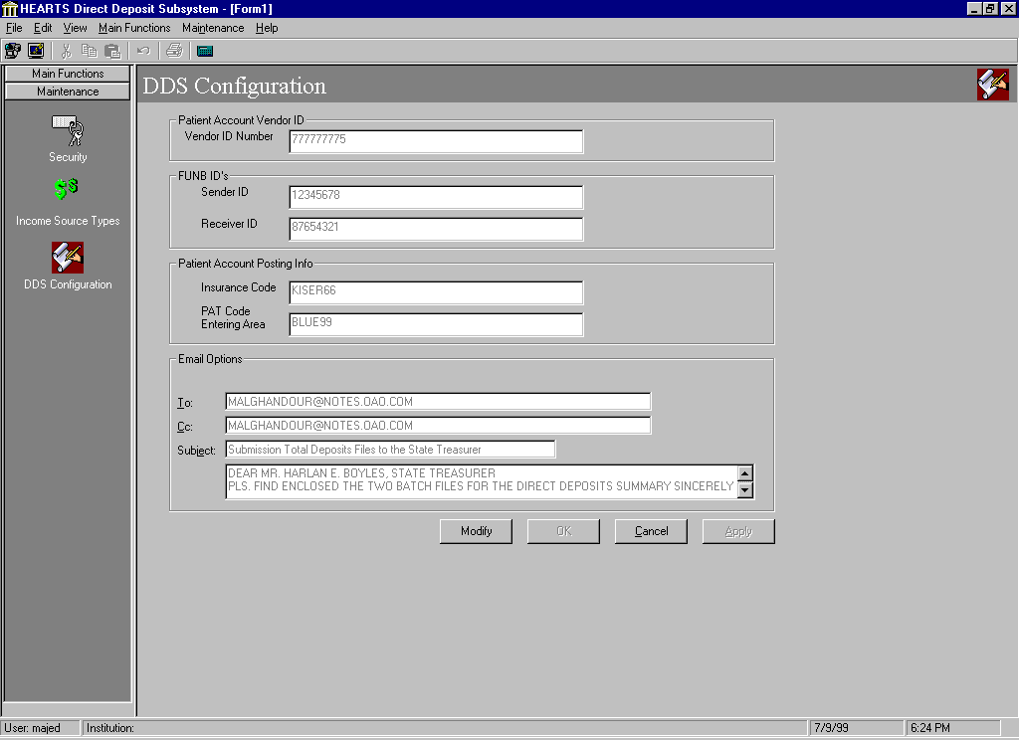
The DDS Configuration Screen is a MDI child and must fill the entire workspace of the Main Screen. In order to accomplish this the screen needs to resize the form and controls to fit the dimensions of the workspace section any time the main form is resized (resolution of 800*600 or greater is necessary).

When the user enters this screen, the OK and Apply buttons are enabled and all active information are displayed in the list. The DDS Configuration Screen is divided into several frames as follows:
- Patient Account Vendor ID
- FUNB (Sender/Receiver) ID’s,
- Patient Account Posting Info., and
- Email Options

The fields in the DDS Configuration screen are read-only when entering the screen. The following objects are needed for this Screen:

Field | Control Type | Group | Comments
lblVID | Label | Patient Account Vendor ID
TxtCode | TextBox | Patient Account Vendor ID
Image1 | Image Box | Patient Account Vendor ID
LblFUNBSenderID | Label | FUNB ID's
LblFUNBReceiverID | Label | FUNB ID's
TxtFUNBSenderID | TextBox | FUNB ID's
TxtFUNBReceiverID | TextBox | FUNB ID's
Image1 | Image Box | Patient Account Vendor ID
Image2 | Image Box | FUNB ID's
Image3 | Image Box | Email Options
Image4 | Image Box | Patient Account Positing Info
txtFT1InsuranceCode | TextBox | Patient Account Positing Info
txtPATEnteringArea | TextBox | Patient Account Positing Info
lblToMultiple | Label | Email Options
LblDate | Label | Email Options
LblTo | Label | Email Options
LblCc | Label | Email Options
LblSubject | Label | Email Options
TxtDate | TextBox | Email Options
TxtTo | TextBox | Email Options
Txtcc | TextBox | Email Options
Txtsubject | TextBox | Email Options
TxtNoteText | TextBox | Email Options
Modify | Command Button
OK | Command Button
Cancel | Command Button
Apply | Command Button

The DDS Configuration screen is used to view, modify information. This screen is used to maintain system information for four areas:

- Patient Account Vendor ID (used in the State Treasurer’s interface)
- FUNB Sender and Receiver ID’s (used to validate BAI files during the Load process)
- Patient Account Posting Info. (used in the HL7 interface to Affinity)
- Email Options (used in the State Treasurer’s interface)

Display Configuration Data
Upon entering the screen all data is displayed. Data is read-only.

Modify Configuration Data
To modify any of the configuration data the user would click on the Modify button. All fields become editable. The cursor will be positioned in the first field. The OK and Apply buttons are enabled and the Modify button will be disabled. If the user clicks on OK or Apply and a required field is blank, a modal dialog will be displayed saying that it must be entered. If the user clicks on Cancel and the data has been modified, a modal dialog will be displayed asking if they want to abandon changes. If the OK or Apply button is clicked and required fields pass data validation, update the database with changes. Refresh the screen with changes.

E. DDS External System Interfaces

E.1. HL7 Interface Design

E.1.1 Business function
The HL7 interface is used to post transactions to the Patient Accounting System (Affinity) from the Direct Deposit Sub-system. The whole process consists of the following steps:

- Query the Valid Records table in database.
- Format the outbound HL7 message.
- Post transaction to Patient Account using HL7 message.
- Post transaction to Personal Funds using stored procedure.
- Update the Valid Records table.

E.1.2 HL7 (P03) Event
The P03 event is used to post transactions. The P03 Detail Financial Transaction (DFT) message is used to describe a financial transaction transmitted between systems, that is, to the billing system for ancillary charges, ADT to billing system for patient deposits, etc. The following table shows the segments for this event.

DFT Detail Financial Transaction

MSH Message Header
EVN Event Type
PID Patient Identification
[PD1] Additional Demographics
[ PV1 ] Patient Visit
[ PV2 ] Patient Visit - Additional Info
[{DB1}] Disability Information
[{OBX}] Observation/Result
{FT1 Financial Transaction
[{PR1 Procedure
[{ROL}] Role
}]
}
[{ DG1 }] Diagnosis
[ DRG ] Diagnosis Related Group
[{GT1}] Guarantor
[
{
IN1 Insurance
[ IN2 ] Insurance - Additional Info.
[ IN3 ] Insurance - Add’l Info. - Cert.
}
]
[ACC] Accident Information

Of all the segments, 4 are required for this event. These are MSH, EVN, PID and FT1. The details of these segments are shown as follows. The specifications are from the official HL7 standard. We still need to negotiate a valid format that is acceptable for Affinity.

E.1.2.1 MSH-Message Header Segment
The MSH segment defines the intent, source, destination, and some specifics of the syntax of a message. The CPC column represents Compucare’s specification.
MSH attributes
SEQ | LEN | DT | OPT | CPC | RP/# | TBL# | ITEM # | ELEMENT NAME
1 | 1 | ST | R | R |  |  | 00001 | Field Separator
2 | 4 | ST | R | R |  |  | 00002 | Encoding Characters
3 | 180 | HD | O |  |  |  | 00003 | Sending Application
4 | 180 | HD | O |  |  |  | 00004 | Sending Facility
5 | 180 | HD | O |  |  |  | 00005 | Receiving Application
6 | 180 | HD | O |  |  |  | 00006 | Receiving Facility
7 | 26 | TS | O |  |  |  | 00007 | Date/Time Of Message
8 | 40 | ST | O |  |  |  | 00008 | Security
9 | 7 | CM | R | R |  |  | 00009 | Message Type
10 | 20 | ST | R | R |  |  | 00010 | Message Control ID
11 | 3 | PT | R | R |  |  | 00011 | Processing ID
12 | 8 | ID | R | R |  | 0104 | 00012 | Version ID
13 | 15 | NM | O |  |  |  | 00013 | Sequence Number
14 | 180 | ST | O |  |  |  | 00014 | Continuation Pointer
15 | 2 | ID | O |  |  | 0155 | 00015 | Accept Acknowledgment Type
16 | 2 | ID | O |  |  | 0155 | 00016 | Application Acknowledgment Type
17 | 2 | ID | O |  |  |  | 00017 | Country Code
18 | 6 | ID | O |  | Y/3 | 0211 | 00692 | Character Set
19 | 60 | CE | O |  |  |  | 00693 | Principal Language Of Message

E.1.2.2 EVN – Event Type Segment
The EVN segment is used to communicate necessary trigger event information to receiving applications. Valid event types for all chapters are contained in HL7 table 0003 - Event type .

EVN attributes
SEQ | LEN | DT | OPT | CPC | RP/# | TBL# | ITEM# | ELEMENT NAME
1 | 3 | ID | B | R |  | 0003 | 00099 | Event Type Code
2 | 26 | TS | R | R |  |  | 00100 | Recorded Date/Time
3 | 26 | TS | O |  |  |  | 00101 | Date/Time Planned Event
4 | 3 | IS | O |  |  | 0062 | 00102 | Event Reason Code
5 | 60 | XCN | O |  |  | 0188 | 00103 | Operator ID
6 | 26 | TS | O |  |  |  | 01278 | Event Occurred

E.1.2.3 PID – Patient Identification Segment
The PID segment is used by all applications as the primary means of communicating patient identification information. This segment contains permanent patient identifying and demographic information that, for the most part, is not likely to change frequently.
PID attributes
SEQ | LEN | DT | OPT | CPC | RP/# | TBL# | ITEM# | ELEMENT NAME
1 | 4 | SI | O |  |  |  | 00104 | Set ID - Patient ID
2 | 20 | CX | O |  |  |  | 00105 | Patient ID (External ID)
3 | 20 | CX | R |  | Y |  | 00106 | Patient ID (Internal ID)
4 | 20 | CX | O |  | Y |  | 00107 | Alternate Patient ID - PID
5 | 48 | XPN | R |  | Y |  | 00108 | Patient Name
6 | 48 | XPN | O |  |  |  | 00109 | Mother’s Maiden Name
7 | 26 | TS | O |  |  |  | 00110 | Date/Time of Birth
8 | 1 | IS | O |  |  | 0001 | 00111 | Sex
9 | 48 | XPN | O |  | Y |  | 00112 | Patient Alias
10 | 1 | IS | O |  |  | 0005 | 00113 | Race
11 | 106 | XAD | O |  | Y |  | 00114 | Patient Address
12 | 4 | IS | B |  |  |  | 00115 | County Code
13 | 40 | XTN | O |  | Y |  | 00116 | Phone Number - Home
14 | 40 | XTN | O |  | Y |  | 00117 | Phone Number - Business
15 | 60 | CE | O |  |  | 0296 | 00118 | Primary Language
16 | 1 | IS | O |  |  | 0002 | 00119 | Marital Status
17 | 3 | IS | O |  |  | 0006 | 00120 | Religion
18 | 20 | CX | O | R |  |  | 00121 | Patient Account Number
19 | 16 | ST | O |  |  |  | 00122 | SSN Number - Patient
20 | 25 | DLN | O |  |  |  | 00123 | Driver's License Number - Patient
21 | 20 | CX | O |  | Y |  | 00124 | Mother's Identifier
22 | 3 | IS | O |  |  | 0189 | 00125 | Ethnic Group
23 | 60 | ST | O |  |  |  | 00126 | Birth Place
24 | 2 | ID | O |  |  | 0136 | 00127 | Multiple Birth Indicator
25 | 2 | NM | O |  |  |  | 00128 | Birth Order
26 | 4 | IS | O |  | Y | 0171 | 00129 | Citizenship
27 | 60 | CE | O |  |  | 0172 | 00130 | Veterans Military Status
28 | 80 | CE | O |  |  |  | 00739 | Nationality
29 | 26 | TS | O |  |  |  | 00740 | Patient Death Date and Time
30 | 1 | ID | O |  |  | 0136 | 00741 | Patient Death Indicator

E.1.2.4 FT1 – Financial Transaction Segment
The FT1 segment contains the detail data necessary to post charges, payments, adjustments, etc. to patient accounting records.
FT1 attributes
SEQ | LEN | DT | OPT | CPC | RP/# | TBL# | ITEM# | ELEMENT NAME
1 | 4 | SI | O |  |  |  | 00355 | Set ID -FT1
2 | 12 | ST | O |  |  |  | 00356 | Transaction ID
3 | 10 | ST | O |  |  |  | 00357 | Transaction Batch ID
4 | 26 | TS | R | R |  |  | 00358 | Transaction Date
5 | 26 | TS | O |  |  |  | 00359 | Transaction Posting Date
6 | 8 | IS | R | R |  | 0017 | 00360 | Transaction Type
7 | 80 | CE | R | R |  | 0132 | 00361 | Transaction Code
8 | 40 | ST | B |  |  |  | 00362 | Transaction Description
9 | 40 | ST | B |  |  |  | 00363 | Transaction Description - Alt
10 | 6 | NM | O | R |  |  | 00364 | Transaction Quantity
11 | 12 | CP | O | R |  |  | 00365 | Transaction Amount - Extended
12 | 12 | CP | O |  |  |  | 00366 | Transaction Amount - Unit
13 | 60 | CE | O | R |  | 0049 | 00367 | Department Code
14 | 60 | CE | O | R |  | 0072 | 00368 | Insurance Plan ID
15 | 12 | CP | O |  |  |  | 00369 | Insurance Amount
16 | 80 | PL | O |  |  |  | 00133 | Assigned Patient Location
17 | 1 | IS | O |  |  | 0024 | 00370 | Fee Schedule
18 | 2 | IS | O |  |  | 0018 | 00148 | Patient Type
19 | 60 | CE | O |  | Y | 0051 | 00371 | Diagnosis Code
20 | 120 | XCN | O |  |  | 0084 | 00372 | Performed By Code
21 | 120 | XCN | O |  |  |  | 00373 | Ordered By Code
22 | 12 | CP | O |  |  |  | 00374 | Unit Cost
23 | 22 | EI | O |  |  |  | 00217 | Filler Order Number
24 | 120 | XCN | O |  |  |  | 00765 | Entered By Code
25 | 80 | CE | O |  |  | 0088 | 00393 | Procedure Code

E.1.3 Programming

E.1.3.1 Client Side
The HL7 interface is mainly implemented in VB on client side with some stored procedure programming on the server side. Several VB classes will be developed to encapsulate the business functions. The network communication protocol is TCP and socket control is used. The socket control used is SocketWrench from Catalyst. Winsock is the standard socket control, which is shipped with VB6 and supported by Microsoft. However, it is limited in functions and not very reliable. SocketWrench is a free commercial ActiveX control, which supports more socket functions and provides more stable connections. So, we picked SocketWrench as the control to use. The whole posting process consists of two procedures. One is used to post all Affinity transactions and the PFS transactions for those records having PFS transactions only. The program flow is shown as following pseudo code segments:

Procedure 1 (initiated by clicking Post Transaction)
Query Valid Records table for recordset
Format the HL7 P03 messages for Patient Account
Post all Affinity transactions to Patient Account
Post transactions to Personal Fund for those records having only PFS transactions

Procedure 2 (initiated by incoming acknowledgement from socket )
Check acknowledgement’s message control ID(Valid Record ID) and posting status
If posting to PA successful
If no associated PF transaction
Move the record from Valid Record table to Posting History table
Else
Post the PF transaction
If posting to PF successful
Move the record from Valid Record table to Posting History table
Else
Move the record from Valid Record table to Invalid Record table
End if
End if
Else
Move the record from Valid Record table to Invalid Record table
End if

E.1.3.2 Server Side
The server side programming to post to the Patient Account is implemented by Compucare. We only need to make sure that the P03 event we send is in the format that is acceptable.

E.1.3.3 Class Diagram
Several classes and modules are designed based upon the HL7 specification. A VB ActiveX project is used generate a single dll which contains the functionality for generating P03 messages. Each HL7 message consists of segments and each segment contains several fields. The clsHL7P03Message class uses modHL7Utils to instantiate clsHL7Field objects and build the clsHL7Segment objects using these field objects. Finally, the segments are added to the clsHL7P03Message object. This object model resembles the Factory pattern except that the create method is in a separate module. The clsHL7Segment, clsHL7Field classes and modHL7Utils module are general. They can be easily reused to generate other kind of HL7 messages. clsHL7AckParser is a stand-alone helper class to parse the acknowledgement from the Hublink.
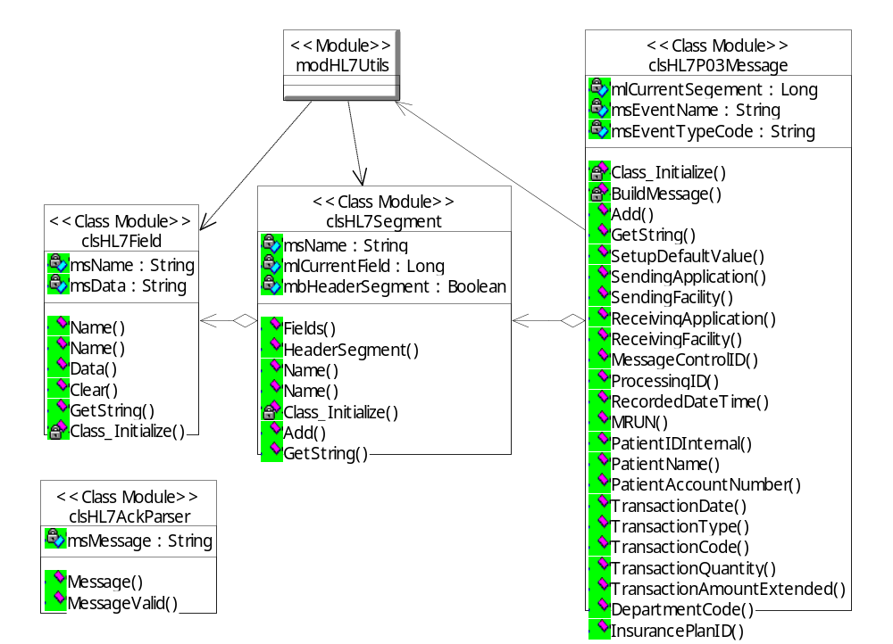
Class Diagram for HL7Server

E.1.4 Sample HL7 Message

Field Name | Value | Field Name | Value
Sending Application | DDS | Sending Facility | 3
Receiving Application |  | Receiving Facility | 3
Date/Time of Message | 7/13/1999 13:00 | Message Type | DFT^P03
Message Control ID | 101 | Processing ID | T
Version ID | 2.3 | Event Type Code | P03
Recorded Date/Time | 7/13/1999 13:00 | Patient ID (MRUN) | 1234567
Patient Name | William Gates | Patient Account Number | 3333333
Transaction Date | 7/13/1999 | Transaction Type | PY (Payment)
Transaction Code | 1201 (VA Benefits) | Transaction Quantity | 1
Transaction Amount | 120.00 | Department Code | PA1
Insurance Plan ID | P01

Based upon the values in the previous table. The following message is generated.
MSH|^~\&|DDS|3||3|||DFT^P03|101|T|2.3||||||||
EVN|P03|199907131300|||||
PID|||1234567||Gates^William^^|||||||||||||3333333|||||||||||||
FT1||||19990713||PY|1201|||1|120.00||PA1|P01||||||||||||

